**Correlation & causation (practice in R)**

**Problem 1:** Testing for marginal correlation

The first thing we need is to load the data into RStudio:

The next step is to apply the attach function to the data so that A and B can be called without accessing data$. Then display observations A and B as a scatterplot:

Output:

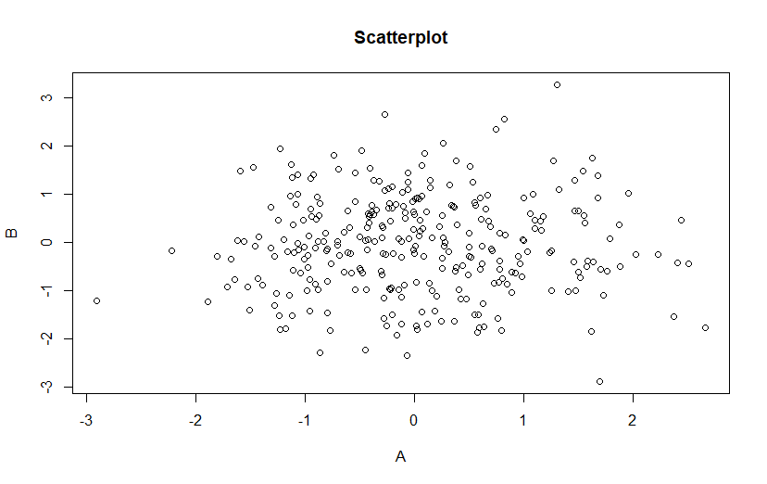

So we don't see correlation. This is consistent with the fact that in Figure 1 they are not connected.

Now we need to check the correlation between A and B:

Correlation = 0.01169715, it is close to zero.

P-value = 0.840103, it is very high (usually we use 0,05).

**Conclusion:** there is no correlation.

**Problem 2: Testing for partial correlation**

To check the partial correlation of A and B we use linear regression and find the residuals:

Then display residuals A ~ C and B ~ C as a scatterplot:

Output:

By the look of the cloud of points, we can assume that it is slightly negatively correlated. Let's also check the correlation:

Correlation = -0.3992521, it is what we expected

P-value = 6.6e-13, so we can be sure in our results

**Conclusion:** As a result, there is a slight negative correlation here. This is consistent with the fact that in Figure 1 A - C and B - C are connected.

**Problem 3: Running the PC algorithm**

To perform this task, install and download the pcalg package, as well as all that was required for further visualization:



Convert the data into the required format:



We run the algorithm for different alpha values and visualize the resulting graphs:

Output:

We see that for large alpha the graph is fully connected.

With decreasing level of significance more and more edges are removed.

We also see that at alpha up to 1e-4 the connection between C and D is removed while the connection between B and E is still two-sided.

**Conclusion:** accordingly, it is not possible to achieve the same dependence as in Figure 1.